**TASK 1:**

#include<iostream>

using namespace std;

int main()

{

int num;

int fact=1;

cout<<"Enter a number for factorial";

cin>>num;

for(int i=1;i<=num;i++)

{

cout<<i<<"!=";

for(int j=1;j<=i;j++)

{

cout<<j;

if(j!=i)

cout<<"*";

}

fact*=i;

cout<<"="<<fact<<endl;

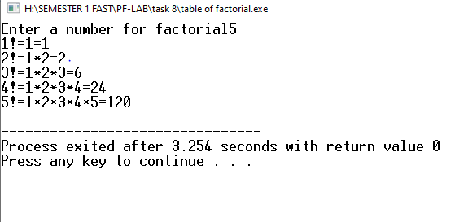

**Task2**

#include<iostream>

#include<iomanip>

using namespace std;

int main()

{

int num,n1,n2,n3;

int a=6;

int p=1;

cout<<"Enter 1 for straight asterick,2 for upside down asterick,\n3 for pyramid of asterick,4 for upside down pyramid of asterick";

cin>>num;

cout<<endl;

switch(num)

{

case 1:

cout<<"Enter height of asterick's triangle";

cin>>n1;

for(int i=1;i<=n1;i++)

{

for(int j=1;j<=i;j++)

{

cout<<"*";

}

cout<<endl;

}

case 2:

cout<<"Enter height of asterick's triangle";

cin>>n2;

for(int i=n2;i>=1;i--)

{

for(int j=1;j<=i;j++)

{

cout<<"*";

}

cout<<endl;

}

case 3:

for(int i=1;i<=5;i++)

{

cout<<setw(a);

{

for(int j=1;j<=i;j++)

{

cout<<"*";

}

a=a-1;

cout<<endl;

}

}

case 4:

for(int i=6;i>=1;i--)

{

cout<<setw(p);

{

for(int j=1;j<=i;j++)

{

cout<<"*";

}

p=p+1;

cout<<endl;

}

}

}

}

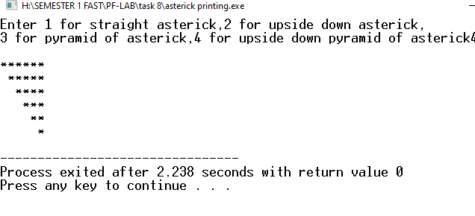

**Task 3:**

#include <iostream>

using namespace std;

int main()

{

int num, option, i, j, k;

cout << " CHOOSE OPTION ";

cin >> option;

int n = num;

int a = 1;

switch (option)

{

case 1:

cout << "ENTER THE LENGTH OF THE TRAIANGLE = ";

cin >> num;

for (i = 1; i <= num; i++)

{

for (j = 1; j <= n; j++)

{

cout << " ";

}

n--;

for (k = 1; k <= i; k++)

{

cout << "*" << " ";

}

cout << endl ;

}

break;

case 2:

cout << "ENTER THE LENGTH OF THE TRAIANGLE = ";

cin >> num;

for (i = 1; i <= num; i++)

{

for (j = 1; j <= n; j++)

{

cout << " ";

}

n--;

for (k = 1; k <= i; k++)

{

cout << " " << a;

a++;

}

cout << endl;

}

break;

case 3:

cout << "ENTER THE LENGTH OF THE TRAIANGLE = ";

cin >> num;

for (i = num; i >= 1; i--)

{

for (j = 1; j <= n; j++)

{

cout << " ";

}

n--;

for (k = num ; k >= i; k--)

{

cout << k << " ";

}

cout << endl;

}

break;

}

system("pause");

return 0;

}

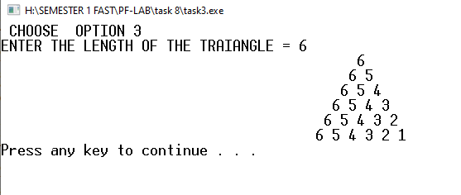

**Task 4**

#include<iostream>

using namespace std;

int main()

{

int x,y,z;

int height;

cout<<"Enter a height of a Diamond:";

cin>>height;

int a=1;

for(x=0; x<=height;x++)

{

for(y=height;y>x;y--)

{

cout<< " ";

}

cout<< "*";

if(x>0)

{

for(z=1;z<=a;z++)

{

cout<< " ";

}

a=a+2;

cout<< "*";

}

cout<<endl;

}

a=a-4;

for(x=0; x<=height-1;x++)

{

for(y=0;y<=x; y++)

{

cout<< " ";

}

cout<< "*";

for(z=1;z<=a;z++)

{

cout<< " ";

}

a=a-2;

if(x!=height-1)

{

cout<< "*";

}

cout<<endl;

}

return 0;

}

